IMDb Movie Rating Scraper - Post Project Report
Automated IMDb Movie Rating Data Extraction and Analysis
Author: Rithika TS (Team03)
Project Type: Individual Project
Project Overview:
The IMDb Movie Rating Scraper is a Python-based automation project designed to extract real-time movie information from IMDb’s official Top 250 Movies list.
Using Selenium WebDriver, the script dynamically loads IMDb’s webpage, waits for the movie table to fully render, and retrieves important attributes like movie title, release year, and IMDb rating.
The extracted data is then stored in a structured CSV file, making it suitable for data analysis, academic usage, and real-world automation tasks.This project demonstrates strong understanding of browser automation, dynamic content scraping, and data handling, making it a valuable addition to both academic records and professional portfolios.
Project Objectives:
The main objectives of this project include:
• Automating the process of scraping IMDb’s Top 250 Movies list
• Handling JavaScript-rendered content with Selenium’s explicit waits
• Extracting structured fields such as title, year, and rating
• Exporting the extracted information into a clean CSV file
• Building a scalable tool that can be extended to collect more information like cast, genres, and storyline summaries
Technical Architecture :
The scraper follows a simple yet effective architecture.
- Selenium WebDriver is used to automate Chrome and load IMDb’s Top 250 page.
- WebDriver Manager handles the automatic installation of ChromeDriver, avoiding manual setup problems.
- The script uses explicit waits to ensure stability, allowing the scraper to extract data only after the required elements load.
To store the results, the project uses pandas, which makes the data easy to manipulate, sort, and export.
- The use of CSS selectors and DOM traversal ensures accurate extraction of movie details.
- Overall, the design is clean, modular, and easy to extend.

Implementation Details:
- The script begins by launching Chrome using WebDriver.
- After navigating to IMDb’s Top 250 page, Selenium waits for the movie table (which loads dynamically via JavaScript) to appear.
- Once loaded, each movie row is scraped individually, retrieving the movie name, release year, and IMDb rating.
A list of dictionaries is created to store the data in memory.
- After the scraping process completes, pandas converts the list into a DataFrame and exports it as a CSV file.
- The project also includes optional headless mode for background execution and uses error-handling techniques to ensure smooth functioning even during network delays.

Performance Analysis:
- The scraper performs reliably due to the use of explicit waits. Unlike static scrapers such as BeautifulSoup, Selenium is capable of handling dynamic DOM changes, making it an ideal choice for IMDb’s JavaScript-heavy pages.
- The execution time remains consistent, and the extracted data is accurate and complete. The generated CSV file is clean and readily usable with analytics tools like Excel, Power BI, Tableau, and Python-based data science libraries.

Strengths of the Project:
• Clean and easy-to-understand Python code
• Efficient extraction of dynamic content
• CSV output improves usability and flexibility
• No manual driver setup needed due to webdriver_manager
• Highly extendable for advanced scraping tasks
• Demonstrates knowledge of automation, data extraction, and pipeline building
Potential Enhancements:
Several improvements can be added to elevate the project further:
• Extracting cast, director, genres, runtime, and storyline
• Adding data visualization such as rating trends or top genres
• Integrating the scraper with a database like MySQL or MongoDB
• Creating a front-end interface using Tkinter, Flask, or React
• Scheduling the scraper to run automatically every day
• Adding logging and exception tracking for production-grade usage
Conclusion:
The IMDb Movie Rating Scraper is a well-built and highly functional automation project. It demonstrates strong technical skills in Python, Selenium, and data handling while maintaining a clear and modular coding approach.
The project is suitable for academic submissions, professional portfolios, and real-world data collection use cases. With scalability and clean architecture, this project provides an excellent foundation for advanced movie data analytics and automation systems.

Source code Screenshot: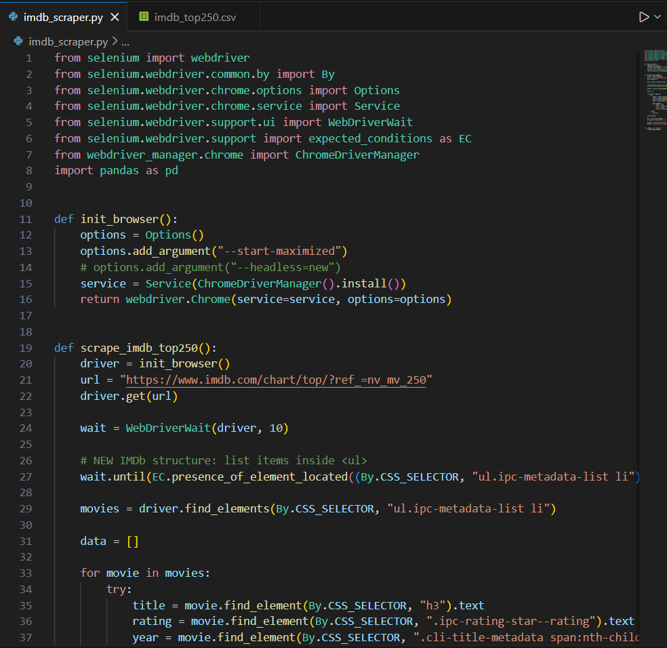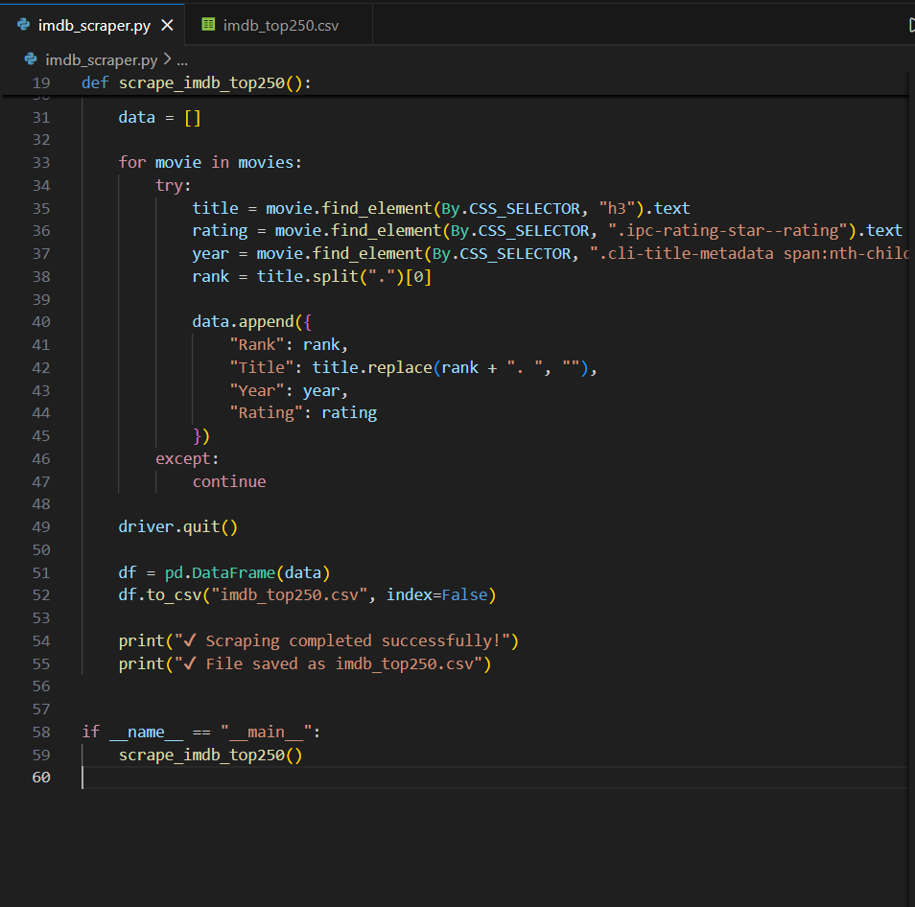

Output Screenshot:
